LAB REPORT NO 02



Computer organization and Architecture (CSE 304L)
Fall 2024
Submitted By: Naveed Ahmad
Registration No: 22PWCSE2165
Section: B
Date: 02/12/2024

Submitted To:
Dr. Ammad Khalil

Department of Computer Systems Engineering
University of Engineering and Technology

TAKS 1:
Printing string using asciiz.
CODE PIC:
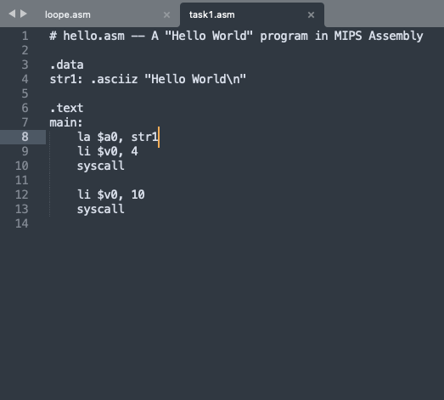

OUTPUT PIC:
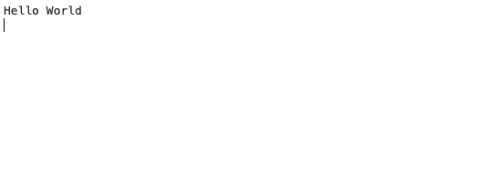

TAKS 2:
Printing Hello World using .byte hexadecimal.
CODE PIC:
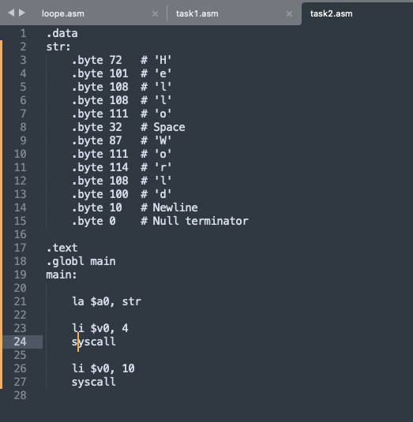
OUTPUT PIC:
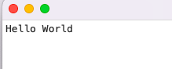

TASK 3:
Conditional Execution: the larger Program.
CODE PIC:
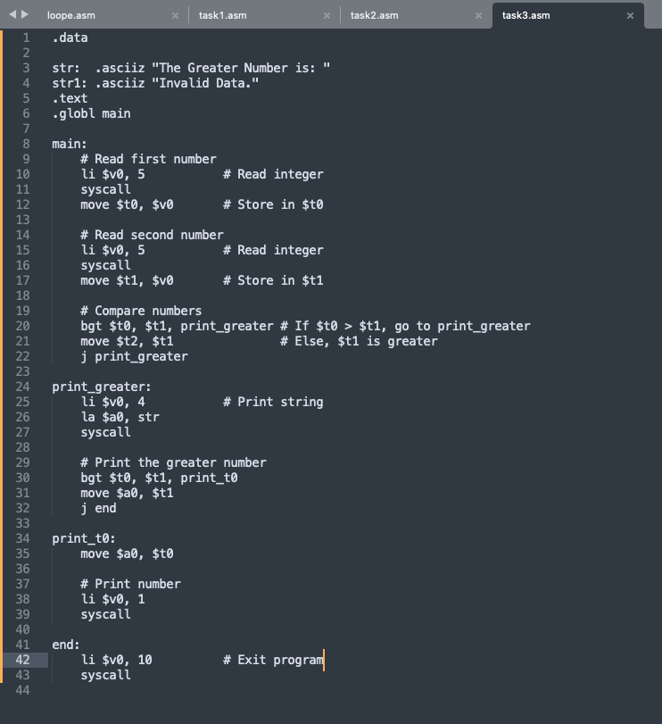
OUTPUT PIC:
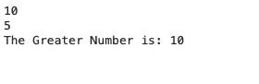
TASK 4:
Looping: the multiples Program.
CODE PIC:
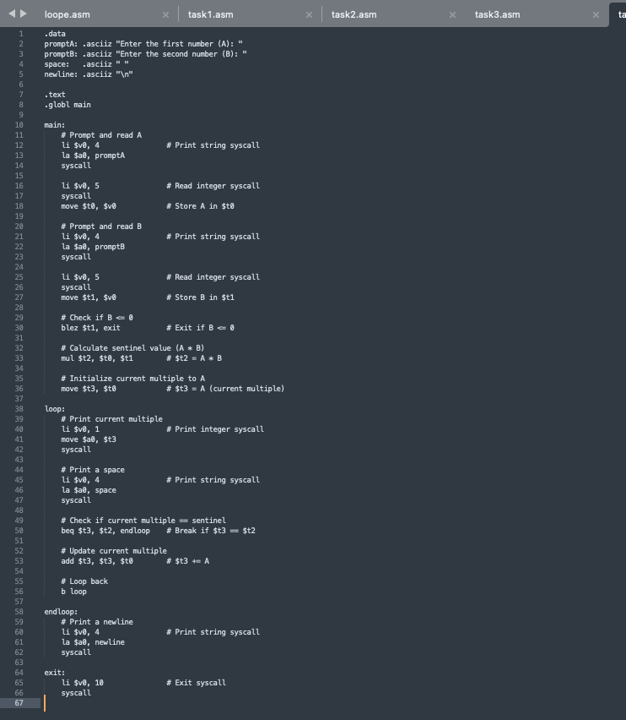
OUTPUT PIC:
